Emerging Health Professionals Youth Work Group
2011-2012

Summary of Youth Work Group

Coachella Valley Economic Partnership Career Pathways Initiative
Healthcare Industry Council
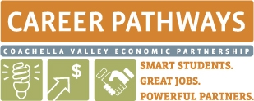

Emerging Health Professionals Work Group

Table of contents

Introduction 3
What is the EHP Work Group? 4
How does the EHP group work? 4
Purpose and Goals 5
Impact 6
School-Chapters 6
Official EHP Work Group- Duties of Officers 7
How to become an EHP Work Group member? 8
General Responsibilities 8
Dress Code 9
Meetings 9
Potential Projects 10
Example Template: Career Portfolio 11
Database Guidelines 12
Appendix
Timeline
PowerPoint Presentation
Invitation Email
Application

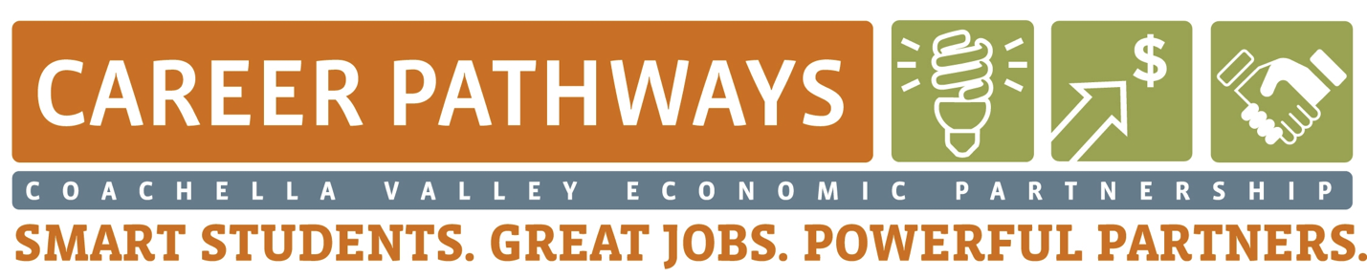
Introduction

The Coachella Valley Economic Partnership, CVEP, is an organization dedicated to expanding and improving the workforce and businesses of the Coachella Valley. CVEP has taken an initiative to improve the workforce by directing some of its focus towards education. In 2005, CVEP launched an initiative called Career Pathways to create a network of opportunities that prepares students for success. Career Pathways identified three major industry clusters that showed great promise for our students and economy – Healthcare, Clean Energy and Arts, Media & Entertainment. The Healthcare Industry Council, HIC, was created to focus on alleviating the healthcare workforce shortage in the valley by addressing educational and career obstacles facing the youth. HIC found it important to incorporate the voice of the youth in the council by developing a youth advisory work group, Emerging Health Professionals Youth Work Group.

What is the EHP Work Group?
Support

- A student-lead youth advisory group for the Healthcare Industry Council
- A communication vehicle between the students interested in a career in the health care profession and the health care professionals of the Coachella Valley
- A support system for other students in the EHP network
Advocate
- A group filled with aspiring youth leaders from the Coachella valley
- A unified group of students interested in healthcare all working towards developing skills that will lead to advancement in their chosen health profession.
- A group that advocates for opportunities in health professions for the region’s students
- A group that leads the discussion representing the youth on the best ways to provide opportunity for the youth
Implement
How does the EHP Work Group work?
Members of the work group:
- Attend Healthcare Industry council meetings regularly
- Actively participate in meetings
- Provide regular youth input
- Identify and prioritize issues pertaining to the healthcare pipeline in the Coachella Valley
- Identify and prioritize possible strategies for addressing issues
Opportunities
- Plan and implement regional events to unify future health professional students
- Create a network of health profession students
- Available as a support system for peers
- Work alongside professionals to co-plan their future

Purpose Statement

CVEP’s Emerging Health Professionals Work Group is a sub-committee of the Healthcare Industry Council that provides Coachella Valley students pursuing healthcare professions a voice and active role in shaping their future. This workgroup formalizes the youth role on the Healthcare Industry Council, assures active participation by allowing regular input, and engages youth in decisions, plans, activities, and efforts that directly affect their future. The work group leads and implements regional activities that allow youth to develop leadership, character, and career development skills. Students will cultivate, practice, and improve necessary skills to ensure their personal career success and to be part of a high quality pool of local youth successful in health professions and a healthy community.
Communicate
Goals
Drive

- Create a leadership structure, Emerging Health Professionals Work Group, which provides the youth of the Coachella Valley with a chance to effectively voice their opinions and thoughts to invoke change on their future.
- Identify and prioritize major issues affecting their future health careers.
- Advantageously gather the tools or resources that are necessary to make realistic career choices and successfully seek employment opportunities available in the health care field then make these resources easily accessible.
Co-Plan
- Student leaders actively participate in discussion and co-plan with industry leaders and education leaders who work towards improving the healthcare workforce.
- Serve as a communication vehicle to represent all youth pursuing a health care profession in the network at the HIC meetings.
Unify
- Drive and implement regional health career activities to unify and engage students interested in health careers
Success
Impact

- A unique regional youth leadership group that provides students with an active role on the Healthcare Industry Council
- Students will have more insight on their future career as a healthcare professional
- Students will gain a tie back to the desert assuring their return to the desert after college
- Students will build strong relationships with the healthcare professionals and the students of the Coachella Valley
- Allow the Healthcare Industry Council insight into the minds of the students and their perception of healthcare
Change
- Students will learn the importance and impact of the healthcare industry on school systems
Identification of tools to successfully move forward
Schools

The Emerging Health Professionals Work Group is open to all high school students involved in health-related pathways/courses/programs/organization/clubs or students who are interested in pursuing a healthcare profession from the following schools:
- Palm Springs High School (PALM Health Academy)
- Cathedral City High School (HEAL Academy)
- La Quinta High School (LQ Medical Health Academy)
- Palm Desert High School (PD Health Pathway)
- Desert Hot Springs High School
- Indio High School (IHS Health Academy)
- Coachella Valley High School (CVHS Health Academy)
- Xavier High School
- Shadow Hills High School
- Desert Mirage High School

Official EHP Work Group – Duties of Officers

- President
12th Grade
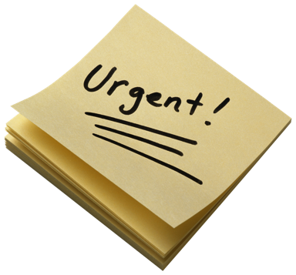
  - Works closely with HIC liaison
  - Works closely with school-chapter leaders
  - Develops meeting agenda
  - Appoints meetings
  - Conducts meetings
  - Keeps activities and meetings on task
  - Encourages support and success
- Vice-President
11th Grade
  - Assist the President
  - Assumes duties and responsibilities in the absence of the President
  - Presides the following year.
  - Available to all members for any assistance
- Secretary
  - Recording officer
  - Keeps minutes and notes of meetings
  - Sends meeting notices
  - Maintains master calendar
  - Maintain database
- Historian
  - Files pictures of activities
  - Maintains EHP bulletin board
  - Assists in planning and advertising events/activities
  - Leads in creating articles or presentations reporting success of EHP

How to become an EHP Work Group member?
An email will be sent out to each of the high schools in the Coachella Valley. The email will be directed towards any teacher/counselor/advisor that leads the health academies or clubs within the school. Those teachers or advisors will offer the opportunity to the students and anybody that is interested in the position will fill out an application. Any chosen teacher/counselor/advisor within that school will review the applications and will select two student leaders that they felt were qualified for the position.
- Invitation email attached. See appendix.
- Application also attached. See appendix.

General Responsibilities of EHP Work Group
- As an Emerging Healthcare Professional, students will be the representatives for their region in the Coachella Valley.
- The impression you make on other people will have a significant impact on how they view CVEP and you, as a future healthcare professional. It is important to always be mindful of the image you portray in appearance, in speaking, in writing, and in professionalism.
- The growth of Emerging Healthcare Professionals confides in your performance and the impression you leave with the people who are interested in EHP. The example that you set will affect each member’s or future member’s enthusiasm and involvement.
- You are responsible for responding timely and appropriately to any member requests for support or assistance.
- As an Emerging Healthcare Professional, you have the challenge of providing guidance, leadership, and inspiration to all EHP members.
- Emerging Healthcare Professionals are required to adhere to the professional dress code.
- Collectively work to meet the needs of CVEP-CPI and all future health professionals
- Show respect and courtesy to fellow members at all times.
- EHP members should always make an effort to understand current health care issues, especially within the Coachella Valley community.
Communication is key to the success of the youth work group!

Dress Code
  - The goal is to improve opportunities for students to succeed in health careers.

EHP Work Group members must dress professionally at all council meetings, work group meetings and EHP events/activities. Think business attire!
- Slacks. Female members may choose to wear knee-length skirt or slacks.
- Closed-toe shoes
- Shirt/blouse for females
- Shirt for males: closed-neck, man-tailored dress shirt, suitable for use with a tie. Male members wear a tie.
Meetings
Set agenda ahead of time
Establish venue
Define ground rules
Establish a time frame for each topic to be addressed
Identify a time keeper
Stay on track
Provide an action plan
Acceptable meeting conduct
Preparation for meeting
Get there on time
Listening skills
Respect all members
All members must be included
Keep in mind respectable body language and tone
Report accurately
Take notes

- Follow-up meetings should be scheduled if the objective of the meeting has not been reached
- Check to make sure that everyone is clear on the results or goals and that everyone is committed.
- Think through issues ahead of time so when it’s time to discuss solutions or action plans, everyone is prepared.

Don’t rely on one form of communication. Confirm attendance. Multiple times if you have to and in different ways! Email, phone, text…

Potential Projects
- Tools and resources. Possible deliverable for this year.
  - Review websites like Career Pathways Initiative (www.smartstudentsgreatjobs.org) and Pathways To Success (www.cvpts.com). Research what resources are available to students interested in healthcare, come up with strategies to improve access to these resources, and research what other resources students may need to be successful in pursuing their career.
- Regional Conference
  - Plan and implement a regional conference for students interested in healthcare. This conference should give students a chance to network, learn from each other, practice acquired skills, practice professionalism, practice leadership, etc. This should be a collective event that improves their chances of being a successful employee.
- Year-Round Advocacy Project
  - Advocate a health issue. Promote awareness, solutions, supports, and fundraising for existing supporting organizations.
- Socials
  - Plan socials to give students opportunities to network with other students or professionals. This can be an independent activity or possibly connect with MAS networking events. Contact Cristina Gregorio to discuss possibilities.

- Workshops
  - Develop leadership skills by organizing and implementing workshops for peers on topics that are prioritized by the youth work group.
- Be the voice!
  - Website
  - Promotional video
  - Blogs
  - Surveys
  - Periodic communication
  - Student feedback/progress
- Other things to keep in mind
  - Recognition, Awards
  - Alumni network
  - Middle school work days
  - Help start up Health Academies or HOSA chapters at schools that don’t already have one
  - Career Portfolios (example follows)

Example Template for Career Portfolio
This portfolio is important to have because it will serve as documentation of achievements that will be helpful in many professional situations. (i.e. filling out applications, take to job interviews…)
Components:
- Career Development Plan
  - Resume
  - Career and educational goals
  - Personal goal plan
  - Career and educational plan

- Job-Related Skills
  - Internships or shadowing experiences
  - Documentation of skills demonstrated/practiced/learned
  - Projects
  - Competency certificates
  - Photographs or videos of work/projects
  - Instructor/mentor/preceptor evaluations
  - Progress reports
- Employability Skills
  - Ex: teamwork/interpersonal skills, attendance/punctuality, initiative/dependability, written and verbal communication skills, critical thinking/problem-solving skills
- Activities, Awards, Volunteer Service
  - Leadership activities
  - Sports, clubs, hobbies, extracurricular activities
  - Awards
  - Volunteer or service-learning experiences

Database
Possible metrics to consider
Name | Grade | School | Status (Work group member, EHP network member)

